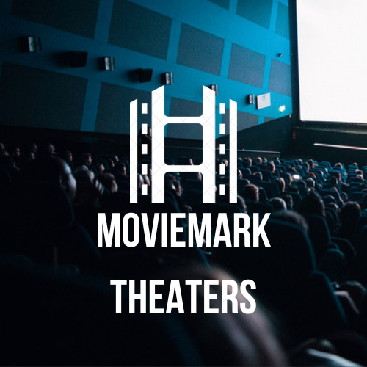

Database Design Report

Camila Gallardo and Mimi Ogunyemi

Professor Bernard COSC 457

Table of Contents

Introduction of Moviemark Towson 2

Objective of Moviemark Towson 3

User Requirements 3

I. Process Modeling Requirements. 4

II. Data Modeling Requirements. 5

Entity Relationship (ER) Diagram 5

Schema Diagram 6

Assumptions 7

Gant Chart 8

Responsibility Matrix 9

Application Design Concepts 10

Conclusion 10

# **Introduction of Moviemark Towson**

Moviemark, a movie theater, is preparing to open a new branch in the Towson area. Many physical aspects, such as the construction of the building, are currently underway. However, some digital aspects are missing. The most important one as of now is a database. Having one would allow the management of the movie theater to run smoothly. Two Towson University students have been recruited to create one for them.

The database will provide different services, including but not limited to, purchasing tickets, offering customer service, a rewards program, as well as offers and discounts. The front end will include a sign-in option. The clients will be able to sign up/log in to an account to purchase tickets and receive points for their purchases. When the points add up to a certain amount, clients will be given the option to use those points for different discounts. The employees will be able to login to purchase, change, or cancel tickets on behalf of the clients. The admins will be able to login and address any customer service issues. They will also be able to manage the movie lease agreements as well as schedule which theaters will play which movies at certain times.

# **Objective of Moviemark Towson**

The objective of Moviemark Towson is to research, understand, and implement the information we learned throughout this semester to create a database that would be of use to a select company, in this case, Moviemark Towson. Moviemark Towson intends to serve the Towson downtown community by providing access to high-quality top-rated movies to residents of the Towson Metropolitan and more.

# **User Requirements**

## Process Modeling Requirements.

Moviemark is a new movie theater opening up a branch in the Towson area. In this theater, we plan to have many customers and each customer will have a Name (First Name and Last Name), an email address, password, and a unique username. These customers will be attended to by employees and the employees are divided into three groups: workers, admins, and managers. Each employee will have a Name (First Name and last Name), an email address, a social security number, a phone number, an address, and an ID number. Employees keep track of their time worked by completing a timesheet. There will be a manager that oversees the affairs of everyday business. The manager will also have a unique manager code that lets them access classified information relating to the business. The administrator (admin) in the theater will be in charge of handling any technical issues that arise during business hours. The admin will also have a unique admin code and will be in charge of handling all the bills relating to the business (such as amount due, due dates, payment status, and bill type), creating the schedule and showtimes, and contacting distributors. Distributors supply the Moviemark with movies, and the movies are leased for a duration of time. The Distributor will have a unique id, name, phone number, and email address. We would also keep track of the lease start date, lease end date, and lease status (active, inactive). Each leased movie will have a title, a unique movie code, rating, and duration. Once these movies have been acquired, they would be screening in the various theaters at Moviemark. Due to the high number of movies, we need to have a running schedule of events. The schedules will include a schedule key, movie code, theater number, date of showing, and time of showing. If a customer decides to come in on any given day to watch a movie, they will first need to purchase tickets and the tickets need to include a movie code, price, seat number, theater number, ticket date and start time. Regular customers can earn points for their loyalty and redeem their points for rewards provided they register to be a loyalty member. Each reward can be redeemed after reaching a particular number of cumulative points (points_needed). Customers can also spend their accumulated points on concessions at the theater. A food distributor supplies every food item sold at the concession stand and the distributor is uniquely identified by an id number.

## Data Modeling Requirements.

As of now, the customer must register to be a loyalty member and accumulate points. They will also be able to login after registering to see how many points they have accumulated so far. To accumulate points, they can either scan their barcode at the theater when purchasing tickets in-person or automatically when they do it through their account.

* 1. Customer can register to be a loyalty member.
  2. Customer can login after registering.
  3. Customer can scan barcode to earn points at the theater in-person.
  4. Customer can view the list of movies in the movie database.
  5. Above is a list of basic requirements a user/admin might have. The system can be upgraded to accommodate more requirements as they arise.

# **Entity Relationship (ER) Diagram**

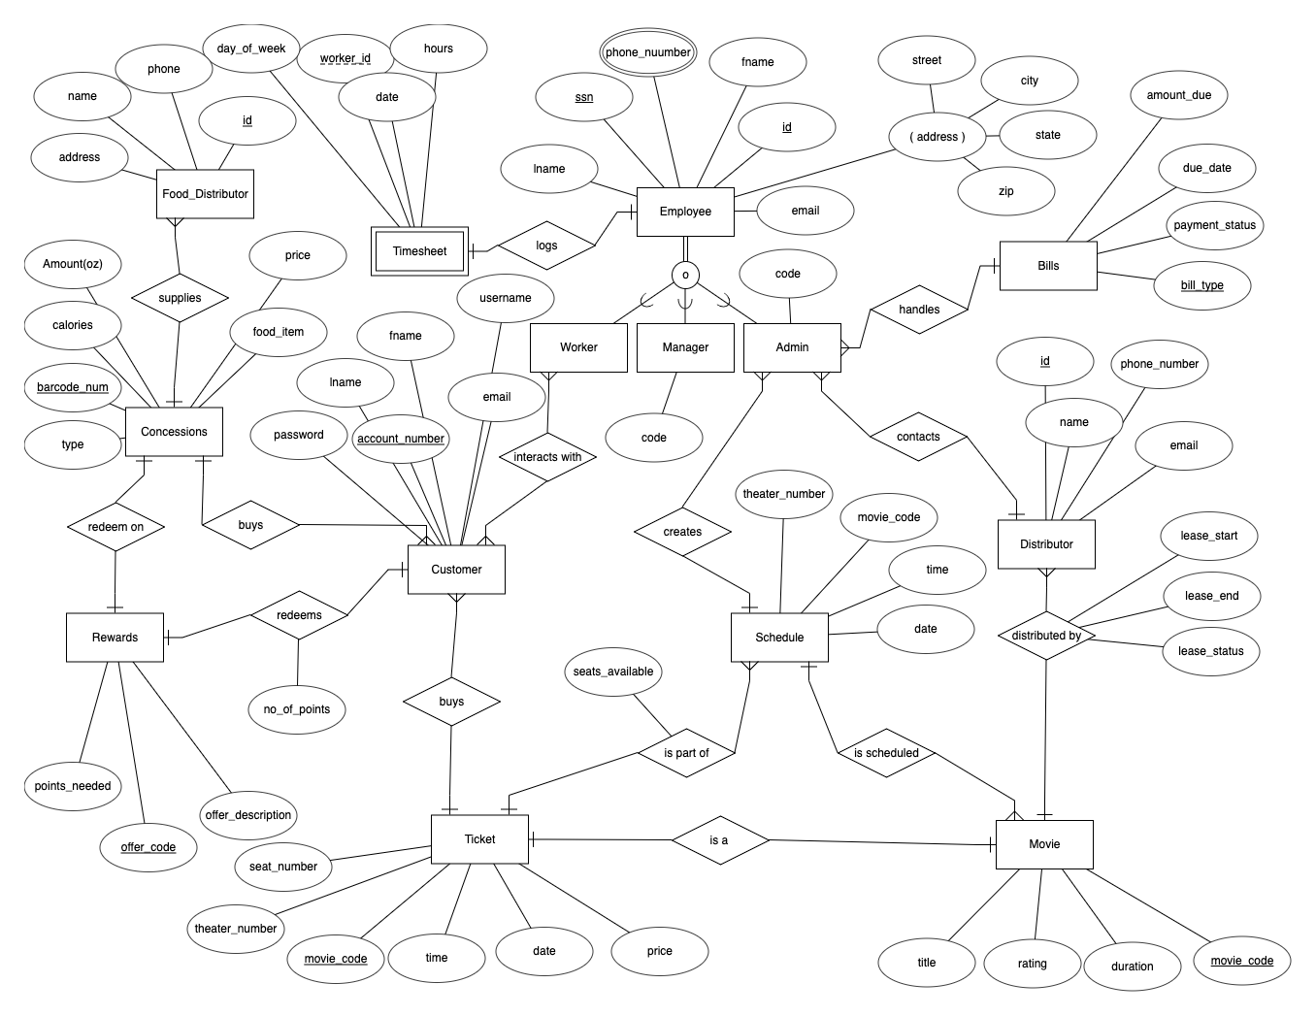

# **Schema Diagram**

# 

# **Assumptions**

* A ticket must have a date, time, movie name, and theater number.
* Customer must have an account to purchase tickets.
* It is not required for a customer to interact with an employee to buy/redeem purchases.
* An admin must oversee the scheduling of movies.
* Only Admins have access to distributor information and bills.
* Employees must fill out a timesheet if they have worked that day.

# **Gant Chart**

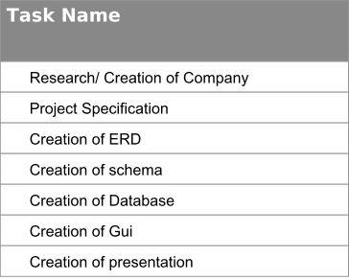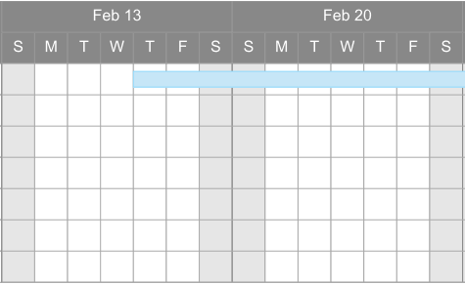

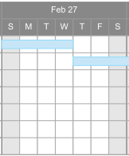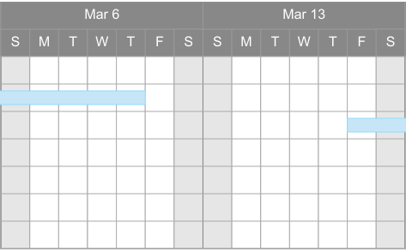

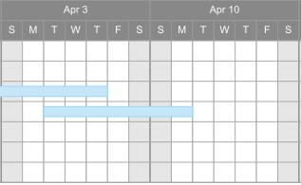

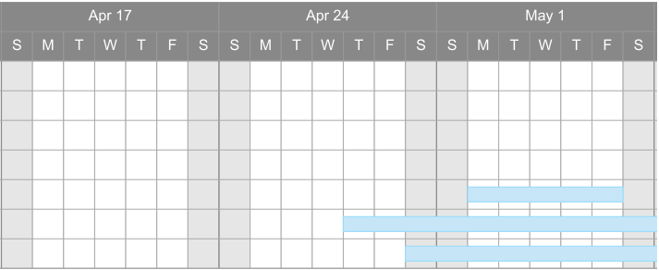

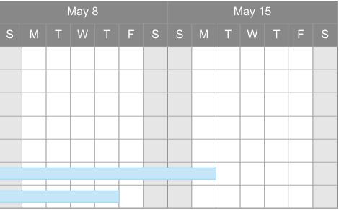

# **Responsibility Matrix**

|  |  |
| --- | --- |
| Deliverables | Member(s) |
| User Requirements | All |
| ERD | All |
| Schema | All |
| GUI | Mimi |
| Database Creation | Camila |
| Database Inserts | All |
| Database Design Report | All |
| Tutorial Manual | All |
| Reference Manual | All |
| Flyer | Camila |

# **Application Design Concepts**

For this project we used the following applications:

* Database Management System (DBMS): MySQL and MySQL workbench
* Programming Language: Java
* Development Environment: IntelliJ IDEA CE, Scene Builder

# **Conclusion**

We hope that with this new database, Moviemark will be able to accommodate their needs and be able to use it for everyday use.